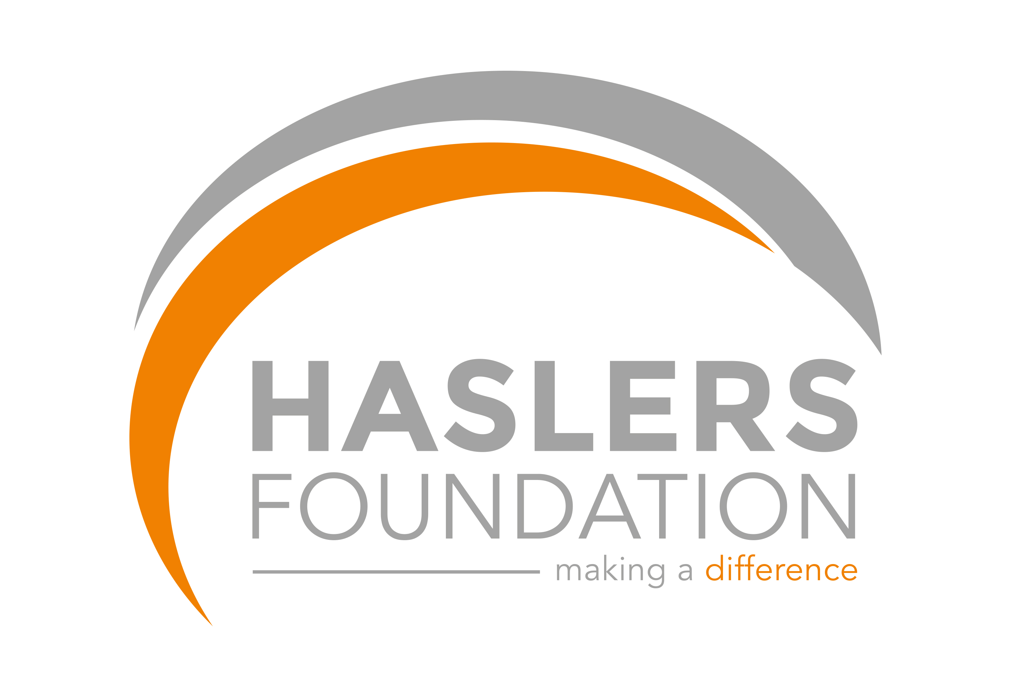

Grant Application Form

APPLICATION FOR A GRANT

INTRODUCTION

The Haslers’ Foundation (“the Foundation”) receives many charitable requests for financial support. To enable all requests to be considered fully and fairly, the attached application form must be completed in full and submitted according to the guidelines below:

The objectives of the Foundation are as follows:

HASLERS FOUNDATION CHARITY

OBJECTIVES

The objectives of the Charity are:

- To prevent or relieve poverty and financial hardship in the Charity’s operational area* by providing grants, items and services to individuals in need and/or charities, or other organisations working to prevent or relieve poverty;

- To support those with sickness and long-term medical conditions and to preserve the health among people residing permanently or temporarily in the Charity’s operational area*;

- To advance in life and help young people through:

  - The provision of recreational and leisure time activities provided in the interest of social welfare, designed to improve their conditions of life;

  - Providing support and activities which develop their skills, capacities and capabilities to enable them to participate in society as mature and responsible individuals;

  - Advancing education

- To contribute, financially, to any charity registered in England and Wales.

*Operational area defined as all IG, RM, SS, CM, EN, E, EC and N postcodes. CB10, CB11, SG12, SG13 and SG14 are also included.

EXCLUSIONS

The Foundation will not support any charities outside of our operational area, nor any charities with any religious or political affiliation or direction.

PROCESS

Applications for charitable support should be submitted to the Foundation via foundation@haslers.com or in writing to:

Haslers’ Foundation
Old Station Road
Loughton
Essex
IG10 4PL

APPLICATION
Applications will only be considered submitted in the attached format which cannot be altered. This will ensure that all applications are considered on the same basis.
Application Form
About your organisation

Name

Registered charity number
(if applicable)

Address

Telephone number

Contact name

Contact e-mail address

Website

Geographical location(s)

Summary of your aims
and objectives

Funding

Detail the main sources of your income (including any funding from corporate partners)

This year:
Source

Amount

What was your
income last year

Provide a breakdown of
the main categories of
expenditure and indicate
what percentage of income
was spent on administration

Application

State the amount you would like The Foundation to consider granting

Give full details regarding what this amount will fund, including the direct impact it will have

What proportion of the overall spend on the project does this represent? If not the full amount, has the remainder of the funding already been sourced? Please provide details and supporting documentation, including names of any corporate or other main contributors (e.g. trusts/government funding)

If The Foundation does not provide any funding what impact will this have on the project?

How many people will directly benefit as a result of a grant from the Foundation?

What are the aims and objectives of this specific project?

How and when will the project’s aims and objectives be achieved?

Connection with The Foundation
Please let us know how you came to hear about The Foundation

Further information

Provide additional information which supports this application

Application authorisation

Signed

Name

Date of application

